

**YEAR: 9**

**2018**

**SUBJECT: Science**

**TEST: Regulation and Control**

**TIME: 40 minutes**

**QUESTIONS: 10 Multiple Choice (10 marks)**

**5 Short Answer (18marks)**

**TOTAL MARKS: 28 marks**

**DO NOT WRITE ON OR MARK THIS PAPER**

Section 1 – Multi-choice **(10 marks)**

The next two questions refer to the section of the brain illustrated below.

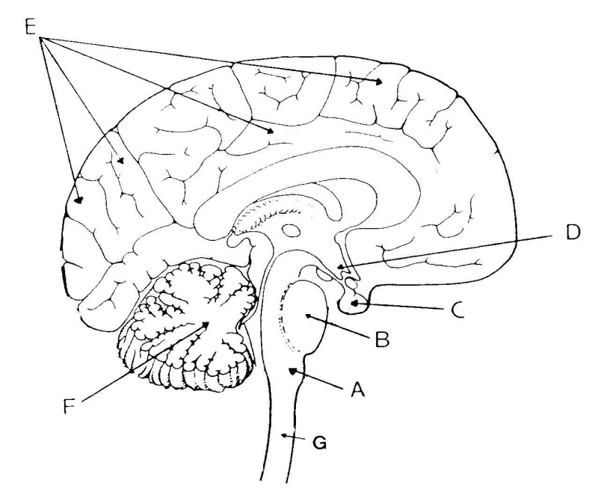

1. Structure E is the

a) hypothalamus.

b) cerebrum.

c) cerebellum.

d) medulla oblongata.

2. The part of the human brain that contains vital centres for regulating heartbeat and   
 breathing is structure:-

a) A  
 b) B  
 c) C  
 d) D

3. In the darkened room, Joel felt a sticky cobweb suddenly cover his face, and he

immediately pulled away. Which type of receptor was used for this action?

a) Vision

b) Taste

c) Touch

d) Sound

4. Which of the following reflexes has to be learnt?

a) Knee-jerk  
 b) Withdrawal of fingers when they touch a hot object  
 c) Catching a ball  
 d) Swallowing

Question 6 refers to the diagram below showing a cross section of the spinal cord.

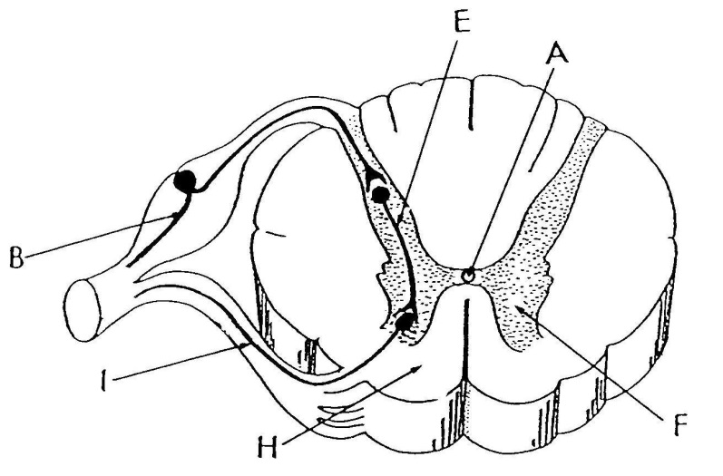

5. Which of the following is correct?

a) H is grey matter which contains nerve cell bodies.

F is white matter which contains myelinated fibres.

b) H is grey matter which contains myelinated fibres.

F is white matter which contains nerve cell bodies.

c) H is white matter which contains myelinated fibres.

F is grey matter which contains nerve cell bodies.

d) H is white matter which contains nerve cell bodies.

F is grey matter which contains myelinated fibres.

1. 6. Identify the activity that would be difficult after sustaining damage to the
2. cerebellum.

a) speech

b) walking

c) breathing

d) intellectual thought.

1. 7. Name two parts of the autonomic nervous system.

a) Central nervous system and parasympathetic nervous system

b) Peripheral nervous system and parasympathetic nervous system

c) Sympathetic nervous system and parasympathetic nervous system

d) Central nervous system and peripheral nervous system.

8. Which of the following is INCORRECT?

a) The central nervous system carries messages to and from all parts of the body.   
 The peripheral nervous system processes information and tells the body how   
 to respond.

b) Motor neurones carry messages from the central nervous system to effectors.   
 Sensory neurones carry messages from cells in the sense organs to the   
 central nervous system.

c) Effectors are muscles or glands that put the messages from the nervous   
 system into effect. Receptors are organs or tissues that have nerve endings   
 that detect changes in the environment.

d) A stimulus is something that you can detect using your sense organs. A   
 response is a reaction to a stimulus.

9. Name the part which occupies more than 80% of the brain and contains over   
 10 billion neurones

a) cerebrum

b) cerebellum

c) brain stem

d) hypothalamus

10.

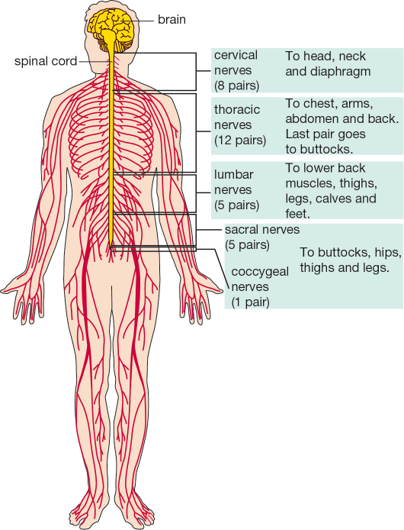

Yanni had an accident that damaged his spinal cord in the lower lumbar region. Some people said he would not be able to walk again because the lower nerves from the spinal cord control movement of the legs. After a time Yanni did learn to walk again. Explain why this was possible.

a) The nerves of the spinal cord regenerated and all messages from the brain

were able to travel as before the accident.

b) The nerves of the lumbar region do not control the ability to walk.

c) The last pair of thoracic nerves and the lumbar nerves above the damaged   
 area could be used to move the muscles needed for walking.

d) It is the brain that controls walking and it was not damaged



**SEMESTER ONE 2018**

**Regulation and Control ANSWER BOOKLET**

**NAME:**

**FORM:** **DATE:**

Multiple Choice Short Answer Total

**/18**

**/10**

**/15**

**/28**

**/30**

**SECTION ONE:** Multiple choice answers

Cross (X) through the correct answer.

|  |  |  |  |  |
| --- | --- | --- | --- | --- |
| **1** | a | b | c | d |
| **2** | a | b | c | d |
| **3** | a | b | c | d |
| **4** | a | b | c | d |
| **5** | a | b | c | d |
| **6** | a | b | c | d |
| **7** | a | b | c | d |
| **8** | a | b | c | d |
| **9** | a | b | c | d |
| **10** | a | b | c | d |

**Section 2 Short Answer**

Questions 1, 2 and 3 refer to the following diagram

People who accidentally put their hand or finger close to a flame experience a ‘reflex’. This involves the hand automatically moving away from the flame. The diagram below shows the nervous pathway involved.

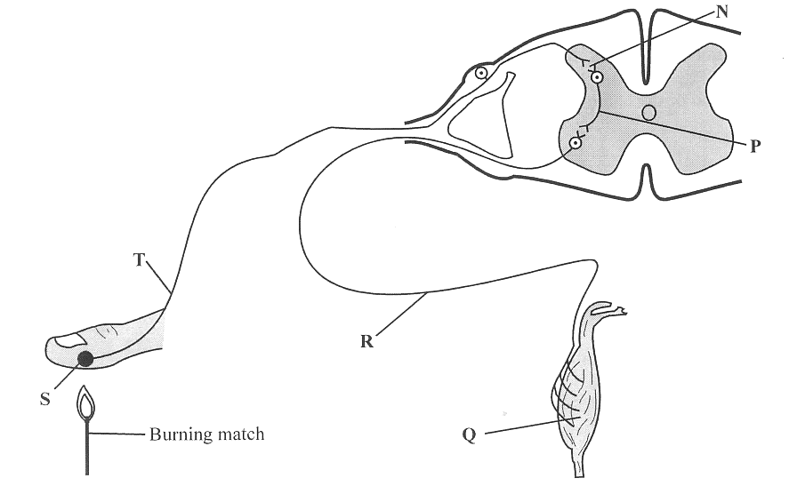

1. Write down the correct letter next to the definition. (5 marks)

a) Sensory neuron. ________________

b) Interneuron (also known as the connector or relay neuron) ____________

c) Muscle __________

d) Stimulus _______

d) Motor neuron ________

2. Draw arrows on the diagram to show the direction of nerve impulses. (1 mark)

3. Why would it be a disadvantage for the message to go to the brain first? (1 mark)

___________________________________________________________________

___________________________________________________________________

4. Look at the diagram below and then fill in the table underneath it.

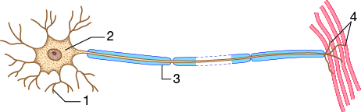

|  |  |  |
| --- | --- | --- |
| Number | Name of structure | Function (What it does) |
| 1 |  |  |
| 2 |  |  |
| 3 |  |  |
| 4 |  |  |

The End of the Test